

=

NAME: SHUMAILA ARIF

ROLL NO: 68279

PROGRAM: BS CYBERR SECURITY

COURSE: INFORMATION SECURITY

SUBMITTED TO: MISS KIRAN FATIMA

Problem Statement:
The goal of this project is to design and manage security policies for an enterprise network by configuring a Network Firewall (Cisco ASA) and applying Access Control Lists to control inbound and outbound traffic.
Simulator:
Cisco Packet Tracer will be used to simulate the design.
Motivation:
The motivation behind this project was to gain practical, hands-on experience in implementing real-world network security concepts. In today’s enterprise environments, securing internal networks from external threats is a critical requirement. This project motivated me to understand how firewalls, NAT, PAT, and Access Control Lists (ACLs) work together to protect organizational data and services. By working on Cisco ASA in Packet Tracer, I was motivated to bridge the gap between theoretical knowledge and practical implementation, which is essential for a career in cybersecurity. This project also enhanced my interest in firewall management and enterprise network security design.
Introduction:
The objective of this Complex Computing Problem (CCP) is to design, configure, and manage enterprise-level security policies using a Cisco ASA firewall. The project focuses on controlling inbound and outbound network traffic through Network Address Translation (NAT), Port Address Translation (PAT), and Access Control Lists (ACLs).
Deliverables:
Design:
The network is designed using a Cisco ASA firewall placed between the inside network (192.168.1.0/24) and the outside ISP network (6.6.6.0/8). NAT and ACLs are implemented to control traffic flow, allow required services, and secure communication between internal users and remote servers. This design ensures controlled and secure enterprise network access.

Complete Network Design

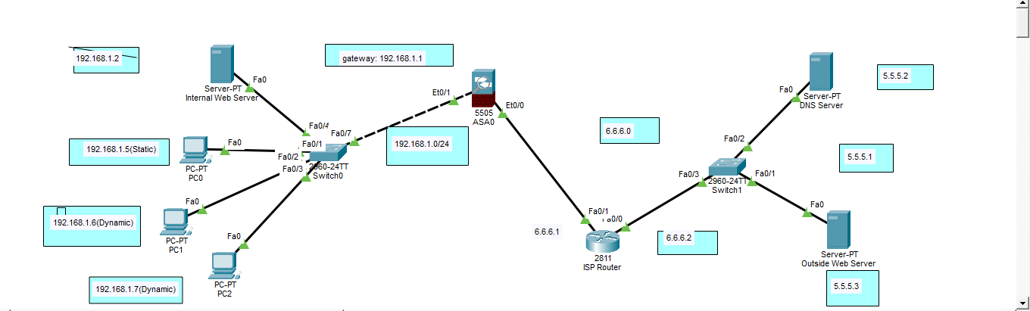
Network Topology Overview
The simulated enterprise network consists of the following components:
- Inside Network: 192.168.1.0 /24
- Cisco ASA Firewall: Acts as the security gateway between inside and outside networks
- Outside Network (ISP): 6.6.6.0 /8
- Remote Server Network: 5.5.5.0 /8
- Remote Web Server: 5.5.5.3
- DNS Server: Configured to resolve domain names to IP addresses
Inside Network (Enterprise LAN)
Device Name IP Address Subnet Mask Default Gateway Description
PC-0 192.168.1.5 255.255.255.0 192.168.1.1 Inside user (Blocked via ACL)
PC-1 192.168.1.6 255.255.255.0 192.168.1.1 Inside user (Allowed)
PC-2 192.168.1.7 255.255.255.0 192.168.1.1 Inside user (Allowed)
Internal Web Server 192.168.1.2 255.255.255.0 192.168.1.1 Internal web services

Cisco ASA Firewall Interfaces
Interface | Security Level | IP Address | Subnet Mask | Purpose
VLAN 1 (Inside) | 100 | 192.168.1.1 | 255.255.255.0 | Inside network gateway
VLAN 2 (Outside) | 0 | 6.6.6.2 | 255.0.0.0 | ISP connection

Outside / Remote Network Servers
Server Name | IP Address | Subnet Mask | Gateway | Service
Remote Web Server | 5.5.5.3 | 255.0.0.0 | 5.5.5.1 | HTTP
DNS Server | 5.5.5.2 | 255.0.0.0 | 5.5.5.1 | DNS

NAT Configuration Table
Inside IP | Public IP | NAT Type
192.168.1.0/24 | 6.6.6.2 | Dynamic NAT
192.168.1.2 | 6.6.6.3 | Static NAT

ACL Policy Summary
Rule No | Source | Destination | Service | Action
1 | Inside Network | 5.5.5.2 | ICMP | Allow
2 | Inside Network | 5.5.5.3 | ICMP | Allow
3 | Inside Network | Remote Web Server (5.5.5.2) | HTTP | Allow
4 | Outside Network | Internal Web Server | HTTP | Allow
5 | 192.168.1.5 | Any | Any | Deny

Testing – Ping & Web Results
Test Case | Result
Inside → 5.5.5.2 (Ping) | Successful
Inside → 5.5.5.3 (Ping) | Successful
Inside → Remote Web Server (HTTP) | Successful
Outside → Internal Web Server | Successful
PC 192.168.1.5 Internet Access | Blocked

NAT / PAT Configuration
To enable communication between the private inside network and the public outside network, NAT and PAT are configured on the Cisco ASA firewall.
3.1 Dynamic NAT (Inside to Outside)
The inside network (192.168.1.0 /24) is translated to the outside interface IP (6.6.6.2) for outbound communication. This allows internal hosts to access external networks while hiding their private IP addresses.
3.2 Static NAT Mapping
The following static NAT mapping is configured:
• 192.168.1.2 → 6.6.6.3
This static mapping provides a consistent public IP address for the internal web server, allowing it to be accessed from the outside network.
3.3 PAT Configuration
Port Address Translation (PAT) is used to allow multiple internal devices to share a single public IP address using different port numbers, ensuring efficient utilization of public IP addresses.
DNS Server Configuration
- DNS Server IP: 5.5.5.3
- A-Record:
  - www.google.com → 192.168.1.2
- A record:
- Iqra.edu.pk→5.5.5.3
This allows inside users to access the remote web server using a domain name.
This configuration allows inside users to access the remote web server using a domain name instead of an IP address.

Access Control List (ACL) Configuration
ACLs are applied on the Cisco ASA firewall to enforce security policies.
Implemented ACL Rules:
- Allow inside users to PING remote servers 5.5.5.2 and 5.5.5.3
- Allow inside users to access the remote web server (HTTP)
- Allow outside users to access the internal web server
- Block Internet access for inside user 192.168.1.5
These ACLs ensure controlled access while preventing unauthorized or restricted traffic.

Testing and Verification
The following tests were performed to verify correct configuration:
- Successful ping from inside hosts to remote servers
- Successful HTTP access to the remote web server using a browser
- Successful access from outside network to the internal web server
- Verification that host 192.168.1.5 is blocked from internet access
Screenshots of each test result are included as proof of successful implementation.
PC 0:
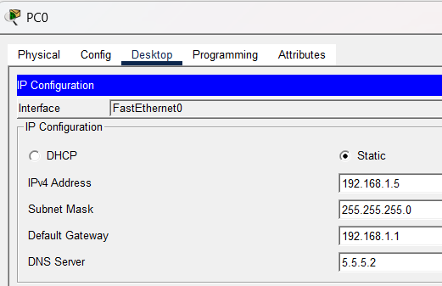

PC 1
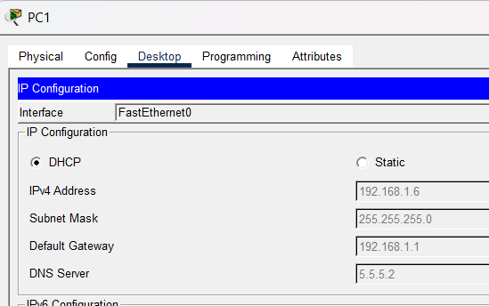

INSIDE WEB SERVER:
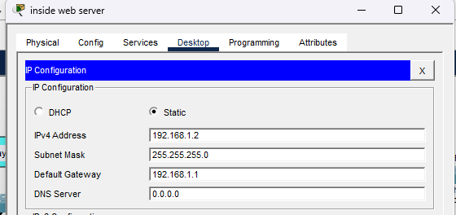

DNS SERVER:
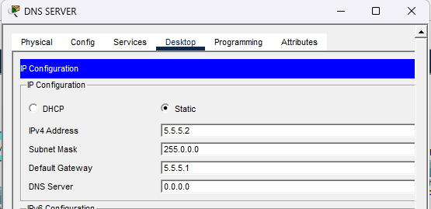
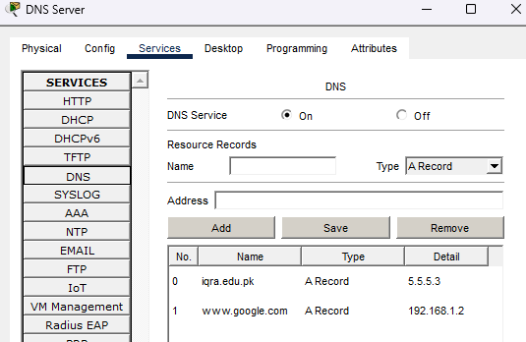

ROUTER
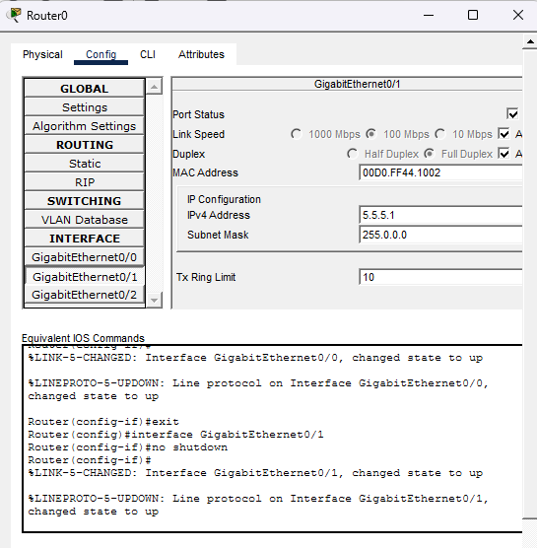
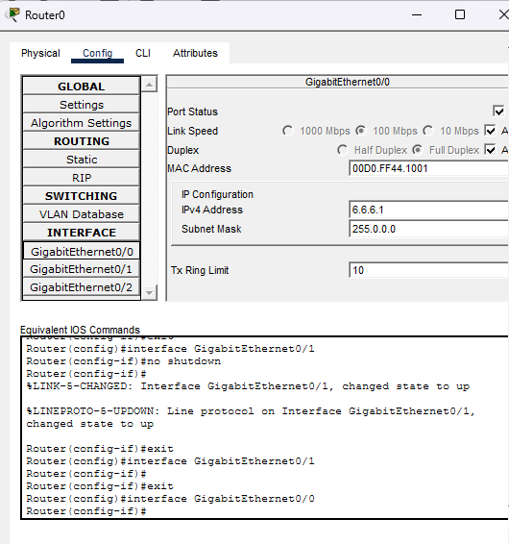

ASA CLI COMMANDS:
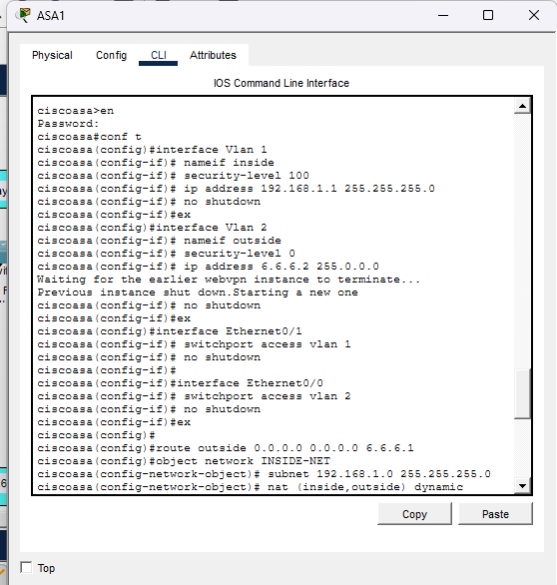
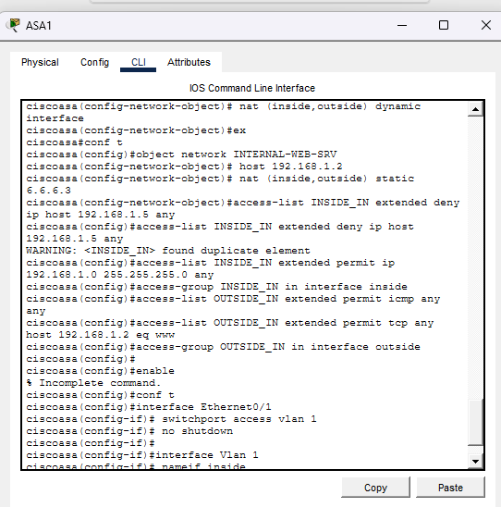
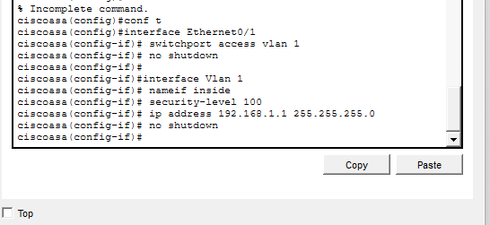

OUTPUT:
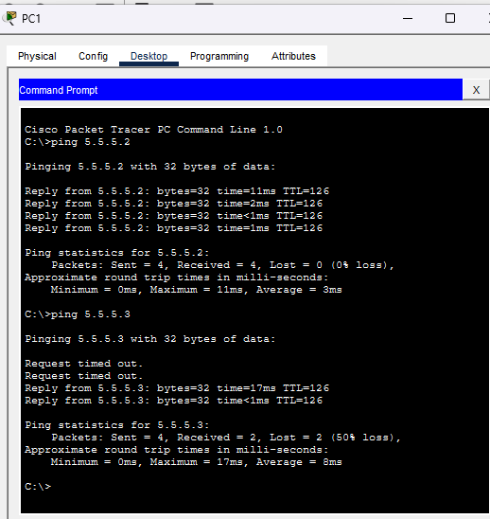
Figure 1: Successful ping from PC-1 to remote server 5.5.5.2

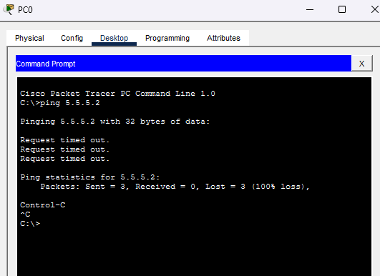
Figure 2: Internet access blocked for PC 192.168.1.5

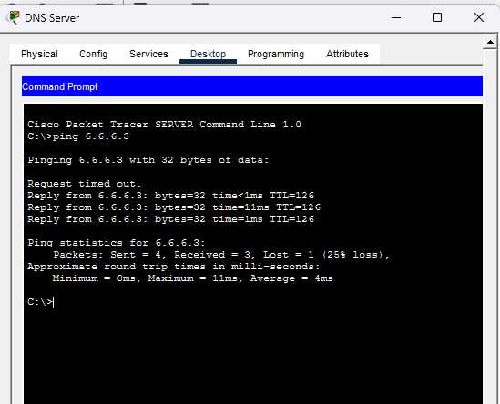
Figure 3: successful ping from DNS server to inside network

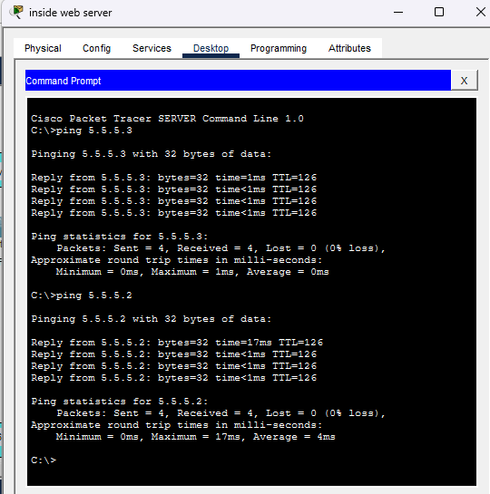
Figure 4: Successful ping from insider server to remote server 5.5.5.2 and 5.5.5.3
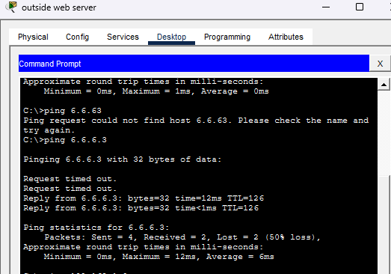
Figure 5: Successful ping from outsider server to 6.6.6.3

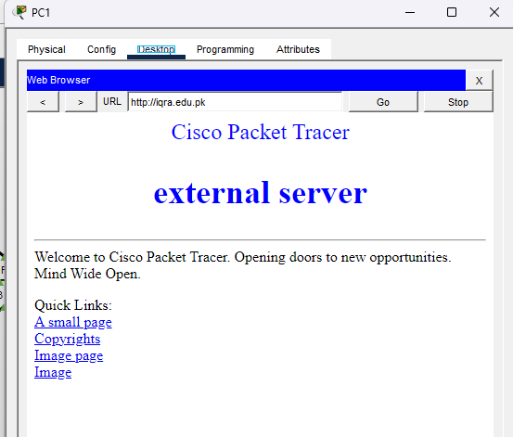
Figure 6: Successful browse from pc 1 to DNS server

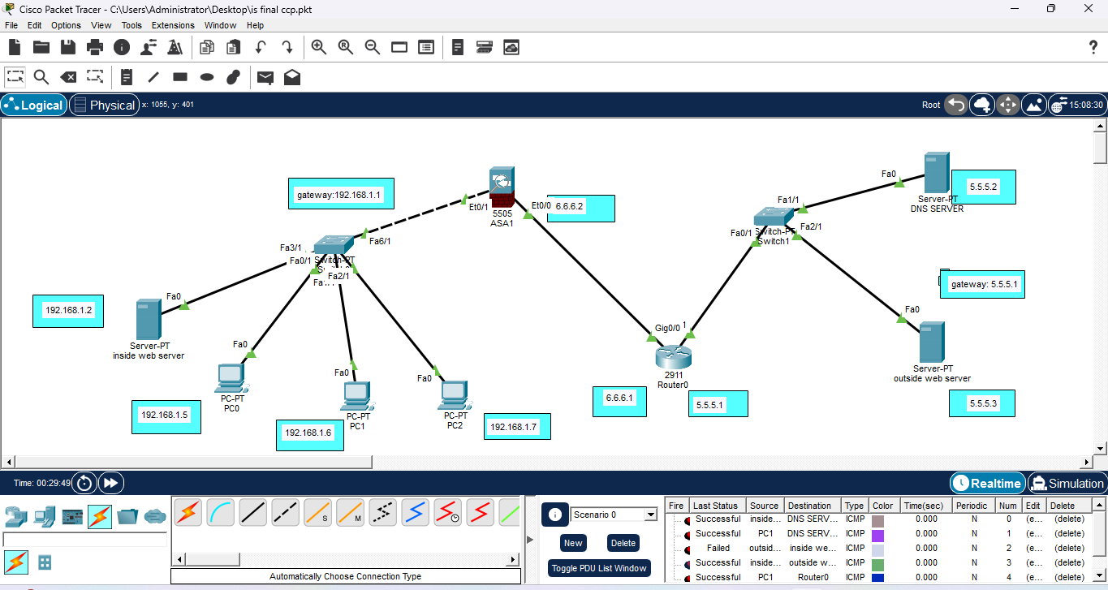
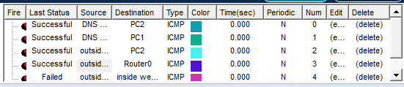

Tools Used
- Cisco Packet Tracer – Network simulation
- Cisco ASA Firewall (CLI) – Security configuration
- PCs and Servers – End devices for testing

Learning Outcomes
Through this project, I learned how enterprise firewalls are configured to secure networks using NAT, PAT, and ACLs. I gained hands-on experience with Cisco ASA CLI commands and understood how traffic flow is controlled between internal and external networks. This project strengthened my practical understanding of enterprise firewall deployment and security policy enforcement using Cisco ASA.

Challenges Faced
- Understanding the correct order and placement of ACL rules
- Troubleshooting NAT issues when traffic was not passing
- Ensuring correct IP addressing and interface configuration
These challenges improved my problem-solving and debugging skills.
Role of NAT and ACLs in Enterprise Security
NAT helps in hiding internal IP addresses, enhancing security by reducing direct exposure to the internet. ACLs provide fine-grained control over network traffic, ensuring that only authorized communication is allowed. Together, they form a strong foundation for enterprise network security.
Concluding Remarks:
In this project, I learned how to secure a corporate network using a Cisco ASA Firewall. I implemented Stateful Packet Inspection (SPI) to allow ICMP traffic while maintaining security. The use of Static NAT (6.6.6.3) was crucial to allow outside users to access our internal web server without exposing its real private IP address (192.168.1.2). This setup ensures that the server is reachable while the internal network structure remains hidden from potential attackers. Furthermore, by configuring Standard ACLs, I successfully restricted internet access for specific users (PC0) while allowing others (PC1/PC2), achieving a balance between strict security and business connectivity."\

